Addis Ababa University
Science Faculty
Department OF MATHEMATICS
Math 231B: Mid-Semester Examination

Date:
Time:

Name: _____________________________ I.D. No. _________________
Department: _________________________

Instruction: Attempt all questions and give the answers with the necessary work steps clearly and neatly on the answer sheets.

- Points A = (3, 4, 5), B = (4, 5, 6), C = (7, 9, 3) and D = (10, 12, 6) are given.
Show that 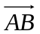 and 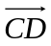 vectors are parallel?
- Find the angle between the vectors 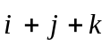 and 2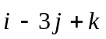
- Find the coordinates of vector = ⟨-1, 3, 1⟩ relative to the ordered basis
B = {⟨2, 1, 0⟩, ⟨2, 1, 1⟩, ⟨2, 2, 1⟩}
- Let A = 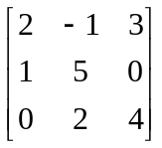
If 3A + 2x = I find x?
- Let x₁ = a₁₁y₁ + a₁₂y₂
x₂ = a₂₁y₁ + a₂₂y₂ and let y₁ = b₁₁z₁ ₊ b₁₂z₂
x₃ = a₃₁y₁ + a₃₂y₂ y₂ = b₂₁z₁ + b₂₂z₂
Express x₁, x₂ and x₃ in terms of z₁ and z₂

- Evaluate the determinant of the following matrix using only properties of determinant
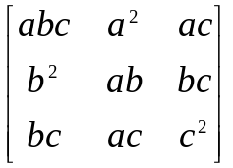
- Find the equation of the plane containing the lines:
L₁: (2, 0, 1) + t(5, 0, -5)
L₂: (1, 3, 5) + s(1, 1, 0) where t and s are real.

- For what values of a, b and d does the following system has more than one solutions
-x + ay = d
2x + 3y = b

- Given A = 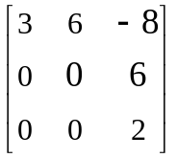
Find the eigenvectors corresponding to the non-zero eigenvalues of matrix A.

